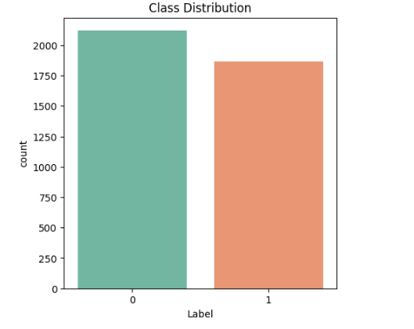

Naïve Bayes Accuracy: 92.9825

LSTM Accuracy: 98.2456

Stacked Model Accuracy: 98.24561403508771

precision recall f1-score support

0 1.00 0.97 0.98 643

1 0.97 1.00 0.98 554

accuracy 0.98 1197

macro avg 0.98 0.98 0.98 1197

weighted avg 0.98 0.98 0.98 1197

Sample Outputs - >

1 > news = "Economists Predict Steady Growth for the Global Economy in the Next Quarter"

print(prediction_input_processing(news))

output - > No, It is not fake

2 >news = "Scientists Reveal: Gravity Is Just a Simulation Designed by Elon Musk!"

print(prediction_input_processing(news))

output -> Yes, It is fake

3>news = "Indian Government Announces New Infrastructure Plan to Boost National Economy"

print(prediction_input_processing(news))

output - > No, It is not fake

4> news = "Breaking: New study reveals that the Earth is and has always been flat and NASA and ISRO have been lying about space for decades!"

print(prediction_input_processing(news))

output -> Yes, It is fake